**Exercise 6: Cursors**

**Scenario 1:** Generate monthly statements for all customers.

**Question:** Write a PL/SQL block using an explicit cursor **GenerateMonthlyStatements** that retrieves all transactions for the current month and prints a statement for each customer.

**PL/SQL Block :-**

DECLARE

CURSOR cur_monthly_transactions IS

SELECT c.CustomerID, c.Name AS CustomerName, t.TransactionDate,

t.Amount, t.TransactionType

FROM Customers c

JOIN Accounts a ON c.CustomerID = a.CustomerID

JOIN Transactions t ON a.AccountID = t.AccountID

WHERE EXTRACT(MONTH FROM t.TransactionDate) = EXTRACT(MONTH FROM SYSDATE)

AND EXTRACT(YEAR FROM t.TransactionDate) = EXTRACT(YEAR FROM SYSDATE)

ORDER BY c.CustomerID, t.TransactionDate;

v_customer_id Customers.CustomerID%TYPE;

v_name Customers.Name%TYPE;

v_date Transactions.TransactionDate%TYPE;

v_amount Transactions.Amount%TYPE;

v_type Transactions.TransactionType%TYPE;

BEGIN

DBMS_OUTPUT.PUT_LINE('--- Monthly Customer Transaction Statements ---');

OPEN cur_monthly_transactions;

LOOP

FETCH cur_monthly_transactions INTO v_customer_id, v_name, v_date, v_amount, v_type;

EXIT WHEN cur_monthly_transactions%NOTFOUND;

DBMS_OUTPUT.PUT_LINE('Customer ID: ' || v_customer_id ||

', Name: ' || v_name ||

', Date: ' || TO_CHAR(v_date, 'DD-MON-YYYY') ||

', Amount: ' || v_amount ||

', Type: ' || v_type);

END LOOP;

CLOSE cur_monthly_transactions;

DBMS_OUTPUT.PUT_LINE('--- End of Statements ---');

**END;**

**/**

**Output :-**

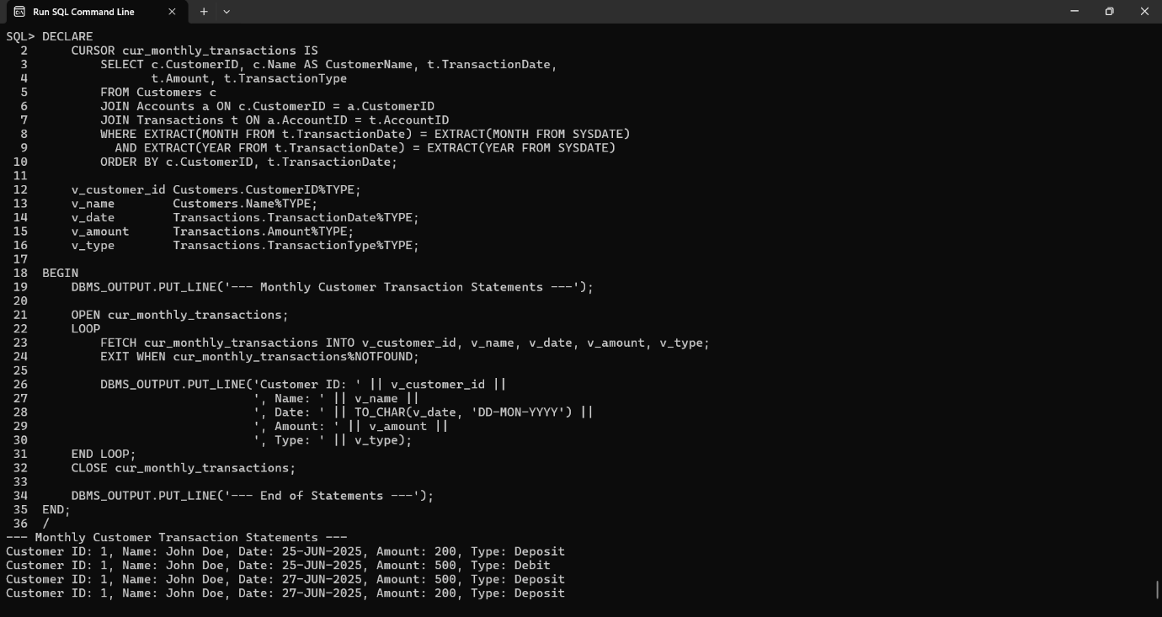

**Scenario 2:** Apply annual fee to all accounts.

**Question:** Write a PL/SQL block using an explicit cursor **ApplyAnnualFee** that deducts an annual maintenance fee from the balance of all accounts.

**PL/SQL Block :-**

DECLARE

-- Annual fee amount

v_annual_fee CONSTANT NUMBER := 200;

-- Cursor to fetch all accounts

CURSOR cur_accounts IS

SELECT AccountID, Balance

FROM Accounts

FOR UPDATE;

-- Variables to hold account data

v_account_id Accounts.AccountID%TYPE;

v_balance Accounts.Balance%TYPE;

BEGIN

DBMS_OUTPUT.PUT_LINE('--- Applying Annual Fee to All Accounts ---');

OPEN cur_accounts;

LOOP

FETCH cur_accounts INTO v_account_id, v_balance;

EXIT WHEN cur_accounts%NOTFOUND;

IF v_balance >= v_annual_fee THEN

UPDATE Accounts

SET Balance = Balance - v_annual_fee

WHERE AccountID = v_account_id;

DBMS_OUTPUT.PUT_LINE('Fee applied to Account ID: ' || v_account_id ||

', New Balance: ' || (v_balance - v_annual_fee));

ELSE

DBMS_OUTPUT.PUT_LINE('Skipped Account ID: ' || v_account_id ||

' due to insufficient balance.');

END IF;

END LOOP;

CLOSE cur_accounts;

DBMS_OUTPUT.PUT_LINE('--- Annual Fee Application Completed ---');

END;

/

**Output :-**

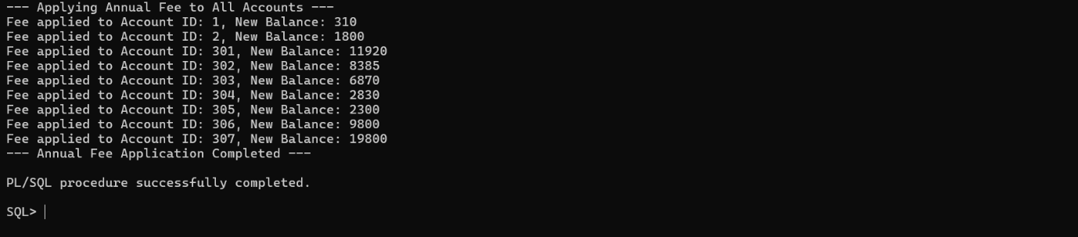

**Scenario 3:** Update the interest rate for all loans based on a new policy.

**Question:** Write a PL/SQL block using an explicit cursor **UpdateLoanInterestRates** that fetches all loans and updates their interest rates based on the new policy.

**PL/SQL Block :-**

DECLARE

-- Cursor to fetch all loans

CURSOR cur_loans IS

SELECT LoanID, InterestRate

FROM Loans

FOR UPDATE;

-- Variables for cursor

v_loan_id Loans.LoanID%TYPE;

v_interest Loans.InterestRate%TYPE;

v_new_rate NUMBER;

BEGIN

DBMS_OUTPUT.PUT_LINE('--- Updating Loan Interest Rates ---');

OPEN cur_loans;

LOOP

FETCH cur_loans INTO v_loan_id, v_interest;

EXIT WHEN cur_loans%NOTFOUND;

-- Apply policy

IF v_interest < 6 THEN

v_new_rate := v_interest + 1;

ELSIF v_interest BETWEEN 6 AND 10 THEN

v_new_rate := v_interest + 0.5;

ELSE

v_new_rate := v_interest; -- No change

END IF;

-- Update if there is a change

IF v_new_rate != v_interest THEN

UPDATE Loans

SET InterestRate = v_new_rate

WHERE LoanID = v_loan_id;

DBMS_OUTPUT.PUT_LINE('Loan ID: ' || v_loan_id ||

' | Old Rate: ' || v_interest ||

' | New Rate: ' || v_new_rate);

ELSE

DBMS_OUTPUT.PUT_LINE('Loan ID: ' || v_loan_id ||

' | Interest Rate unchanged (' || v_interest || ')');

END IF;

END LOOP;

CLOSE cur_loans;

DBMS_OUTPUT.PUT_LINE('--- Interest Rate Update Completed ---');

END;

/

**Output :-**

